**CC2**

**727721EUIT013**

**PART A**

package selen31.testday4;

import org.openqa.selenium.By;

import org.openqa.selenium.WebDriver;

import org.openqa.selenium.chrome.ChromeDriver;

import org.openqa.selenium.chrome.ChromeOptions;­­

import org.testng.annotations.Test;

import io.github.bonigarcia.wdm.WebDriverManager;

public class d7new {

@Test

public void f() {

WebDriverManager.chromedriver().setup();

WebDriver driver;

ChromeOptions co = new ChromeOptions();

co.addArguments("--remote-allow-origins=*");

driver=new ChromeDriver(co);

driver.get("https://www.yatra.com/flights");

driver.manage().window().maximize();

driver.findElement(By.xpath("//*[@id=\"booking_engine_flights\"]/div/span")).click();

driver.findElement(By.xpath("//*[@id=\"BE_flight_form_wrapper\"]/div[1]/div[1]/ul[1]/li[2]/a")).click();

}

}

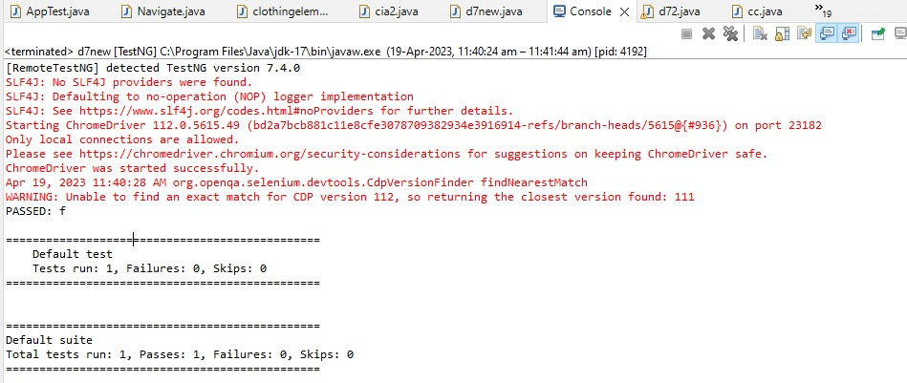

**PART B**